REST API for Stored Procedure

We can give JSON as post input to a SAP HANA Stored Proc using REST API as shown below.

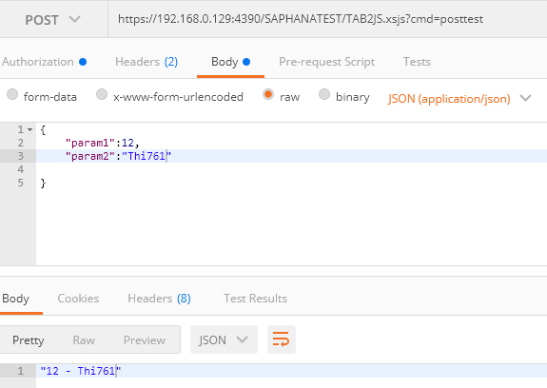

Below is the sample stored proc:

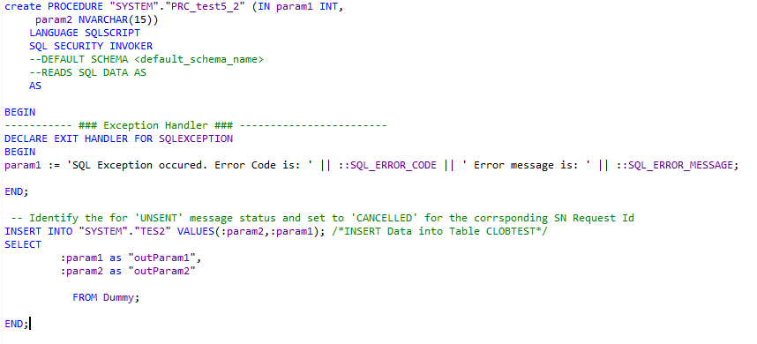

## To create REST API to call Stored procedures follow the steps in the xsodata project:

1. Change the .xsaccess file content to   
   {

"exposed": true,

"authentication": {

"method": "Form"

},

"cache_control": "must-revalidate",

"cors": {

"enabled": true,

"allowMethods": [

"GET",

"POST",

"HEAD",

"OPTIONS"

],

"allowOrigin": ["*"],

"maxAge": "3600"

},

"enable_etags": false,

"force_ssl": false,

"prevent_xsrf": false

}

1. Create a xsjs project
   1. If data is to be passed via url query parameters



This data can be fetched via the below code snippet  
var aCmd = $.request.parameters.get('cmd');

* 1. If data is to be passed as post form data

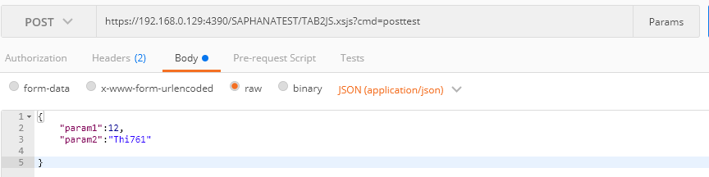

This data is fetched via below code snippet

**if**($.request.method === $.net.http.POST){

**var** jsonString = $.request.body.asString();

**}**

* 1. Now to call a stored procedure and get response,

**var** body = "call \"SYSTEM\".\"PRC_test5_2\" (?,?)";

**var** conn = $.db.getConnection();

**var** cst = conn.prepareStatement(body);

cst.setInt(1,oJson.param1); //pass first parameter of procedure

cst.setString(2,oJson.param2); //pass second parameter of procedure

**try**{

cst.execute();

**var** oResultSet = cst.getResultSet();

**var** result = "";

**while** (oResultSet.next()) {

result = oResultSet.getString(1)+" - "+oResultSet.getString(2);

}

conn.commit();

cst.close();

conn.close();

$.response.contentType = "application/json; charset=UTF-8";

$.response.setBody(JSON.stringify(result));

$.response.status = $.net.http.OK;

}**catch**(e){

$.response.setBody(e.toString());

}